# Code Crunch – Team D

Link to Report:

<https://app.powerbi.com/view?r=eyJrIjoiMTcxMzllNGQtMTc0Yy00MjMxLTk2ZDAtNWJjMmFiZGIzNmI2IiwidCI6ImQ1ZTc2OWIwLWZkMTktNDVlNC1hNGE4LWI3MzU0NTQ1MDIzNCIsImMiOjEwfQ%3D%3D>

Report Screenshot:

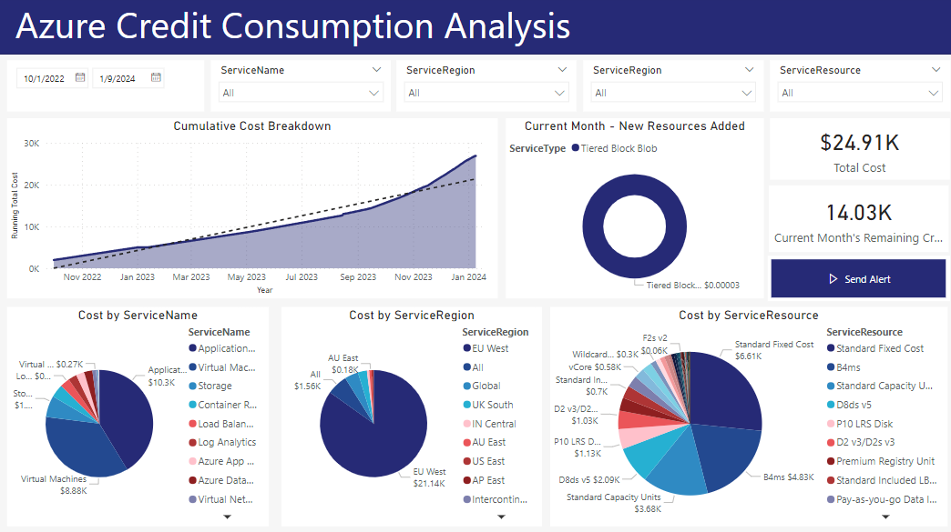

Functions we implemented:

1. Python Script to retrieve what resources have been created newly for the current month. This will be helpful to check whether unnecessary resources have been created and delete them if needed. And also the cost for the newly created items can be analysed.

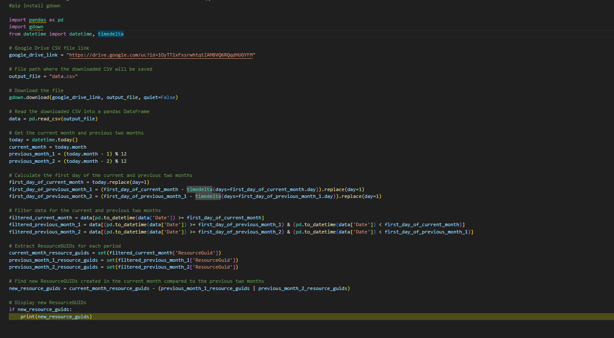

1. A power automate alert has been created to send an email when the remaining Azure credits exceeds 50% of it’s quota. Currently, the benchmark has set to a higher value since this is the beginning of the month and 50% of the credits has not been used yet.

Flow:

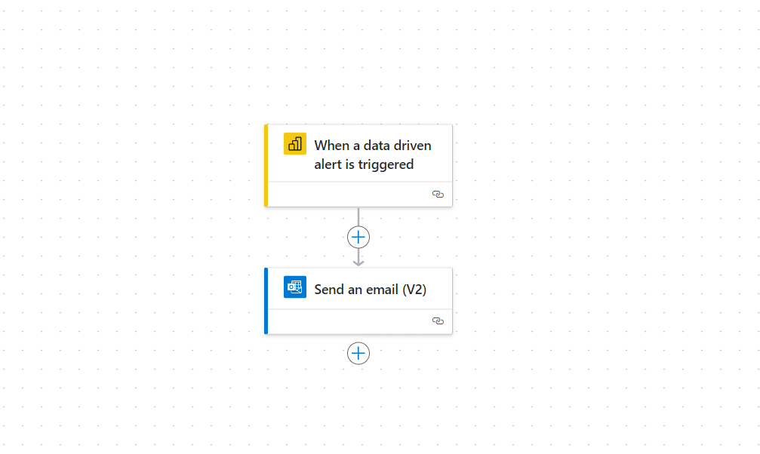

Alert Screenshot:  
